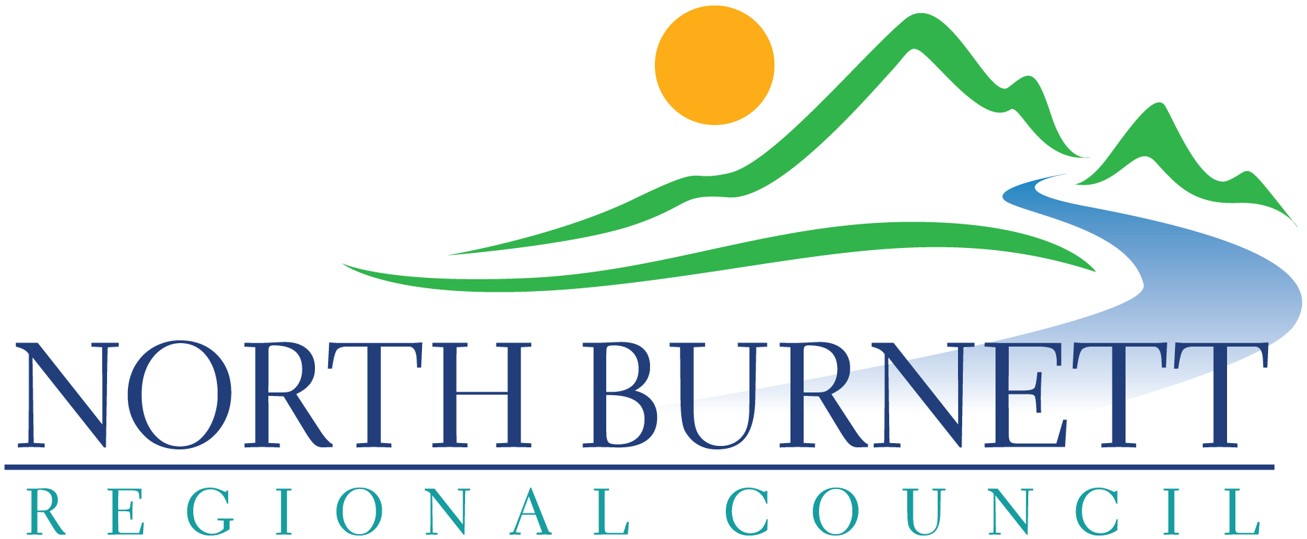 |  | North Burnett Regional Council  Regional Arts Development Fund (RADF)  Auspicing Agreement
☐ Applicant – please forward this form to the auspicing body
☐ Auspicing Body – please fill in and return this form to the applicant
☐ Applicant – please attach this form to your application

We, Click or tap here to enter text.
(Auspicing Organisation’s Name)

of (address) Click or tap here to enter text.

operating under ABN Click or tap here to enter text. (auspicing organisation’s ABN)

agree to auspice (Applicant Organisation’s Name) Click or tap here to enter text.

for their RADF project entitled: Click or tap here to enter text.

We understand that we will be responsible for the following compulsory obligations:
- Receipt, bank and administer all monies
- Monitor the project and ensure timely completion
- Complete the financial acquittal and ensure funding is acquitted on time.

Optional Assistance:
We will also provide the following support to the applicant (please tick relevant items)
☐ Provide insurance for the project
☐ Provide mentoring for the auspiced group

We will / will not charge the group an auspicing fee. This fee will be . % of the amount granted.

Bank Details: Name of Bank: Click or tap here to enter text.

Bank Account Name: Click or tap here to enter text.

Branch No. (BSB) Click or tap here to enter text. Account No. Click or tap here to enter text.

☐ I agree to allow North Burnett Regional Council to use the details provided in this application, including the organisation’s ABN, GST status and address to create an invoice for payment of the grant funds to my organisation and that my organisation will not create its own invoice for this payment.
Name of Auspicing Contact (please print) | Click or tap here to enter text.
Signature of Auspicer
Position in Group of Organisation | Click or tap here to enter text.
Email Address of Auspicing Contact | Click or tap here to enter text.
Contact Telephone Number | Click or tap here to enter text.
Date | Click or tap here to enter text.

Fact Sheet
www.northburnett.qld.gov.au

What is auspicing?

Auspicing means that an organisation that is recognised by the Australian Taxation Office as a not-for-profit type, or which has a legal not-for-profit status, takes responsibility for ensuring the funds are used as specified in the grant allocation.

Your application would need to be auspiced if you are a community organisation, and your group is neither a legally constituted not-for-profit entity nor is recognised by the Australian Taxation Office as a not-for-profit type. Please see table below for eligible statuses:

Legal not-for-profit entities | ATO not-for-profit types
Incorporated Association | Health Promotion Charity
Australian Public Company, Limited by Guarantee | Charitable Institution
Co-operative | Charitable Fund
Trust | Public Benevolent Institution
 | Income Tax Exempt Fund

An auspicing organisation will be responsible for:
- The receipt, banking and administration of all moneys
- Project monitoring and completion
- Ensuring the applicant acquits the funding on time
- Sign off on the acquittal form

An auspicing organisation may also provide the following support to the applicant:
- Provide insurance for the project
- Provide mentoring for the auspiced group

An auspicing organisation may charge a small fee for the above services.

It is the responsibility of the group being auspiced to ensure that a clear agreement is reached before applying for funding. An Auspicing Agreement form (overleaf) must be filled out and included with the application of any auspiced group.

Why should my organisation auspice / sponsor another group?

By auspicing, you may be helping out a new and developing local community group if they are planning a worthwhile project.

It is a great way of ensuring that important projects get off the ground. It can help your group to build long term partnerships.

